RSMC-PETORIA
SWFP GUIDANCE PRODUCTS
SHORT-RANGE (DAYS 1 and 2)
Issued Date: 17th September 2024
SYNOPSIS OF EXPECTED WEATHER PATERNS

Day 1: Tuesday 17th September 2024
Strong winds are expected along the coast of Namibia and the north-east coast of Madagascar. Intense upper trough will result in possible heavy rain from severe thunderstorms over Lesotho and south-eastern interior of RSA. Otherwise, no heavy rain weather in the other areas of the region.
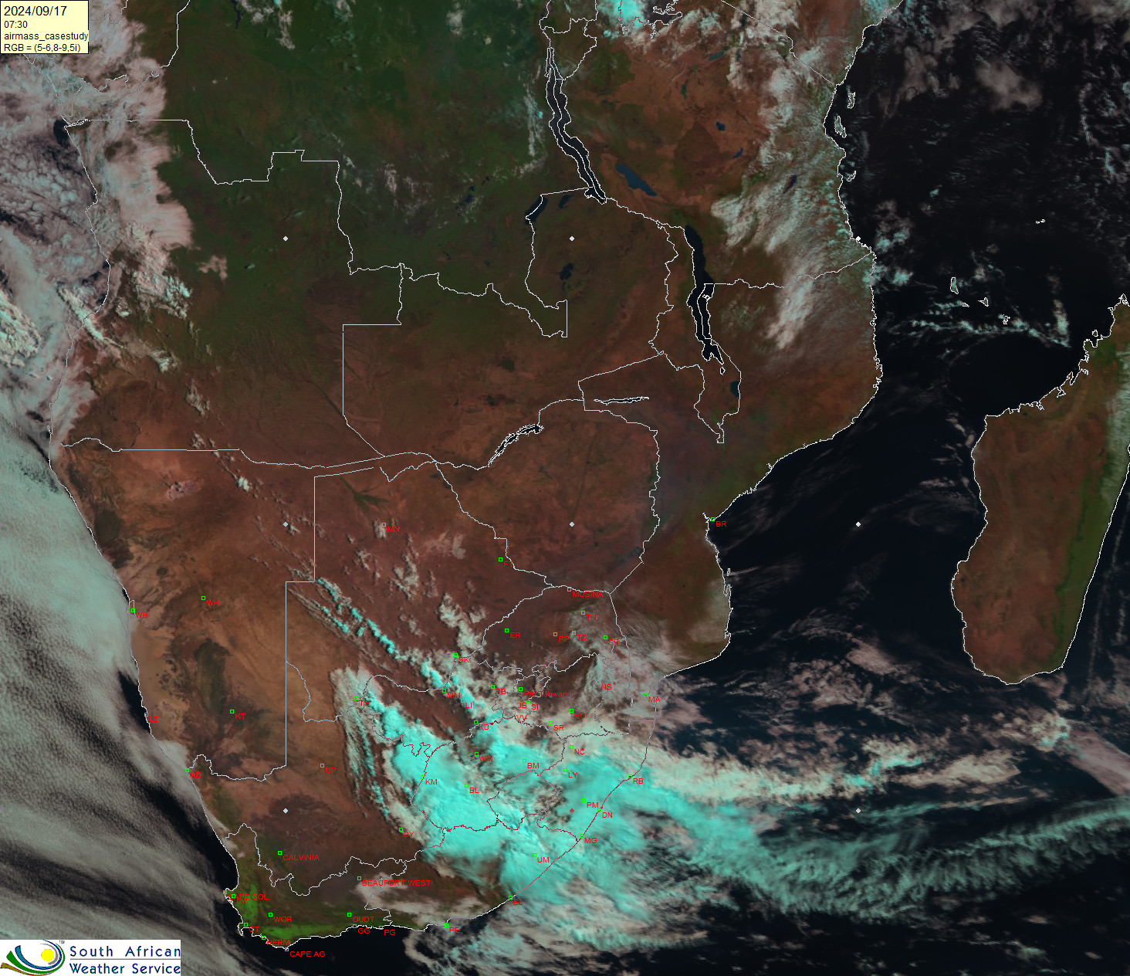
07:30Z
Degree of Confidence: High

Day 2: Wednesday 18th September 2024
Strong winds are expected along the south coast of Namibia, south-west and east coasts of RSA as well as along the south-east and north-east coasts of Madagascar. Rough sea with a total sea of an excess of 4.0m expected along the southwest coast of RSA. Otherwise, no heavy rain weather in the areas of the region.

Degree of Confidence: High

Forecaster: Jacqueline Modika

